**LAB ASSIGNMENT #7**

**STATEMENT:** WRITE A PROGRAM TO IMPLEMENT STACKS (STATIC STACK IMPLEMENTATION). INCLUDE:

1. PUSH
2. POP
3. DISPLAY
4. ISEMPTY
5. ISFULL

**SOURCE CODE:**

#include <stdio.h>

#include <conio.h>

#define MAXSIZE 5

struct stack /* Structure definition for stack */

{

int stk[MAXSIZE];

int top;

};

typedef struct stack STACK;

STACK s;

/* Function declaration/Prototype*/

void push (void);

int pop(void);

void display (void);

void main ()

{

int choice;

int option = 1;

clrscr ();

s.top = -1;

printf ("STACK OPERATION\n");

while (option)

{

printf ("------------------------------------------\n");

printf (" 1 --> PUSH \n");

printf (" 2 --> POP \n");

printf (" 3 --> DISPLAY \n");

printf (" 4 --> EXIT \n");

printf ("------------------------------------------\n");

printf ("Enter your choice\n");

scanf ("%d", &choice);

switch (choice)

{

case 1:

push();

break;

case 2:

pop();

break;

case 3:

display();

break;

case 4:

return;

}

fflush (stdin);

printf ("Do you want to continue(Type 0 or 1)?\n");

scanf ("%d", &option);

}

}

/*Function to add an element to the stack*/

void push ()

{

int num;

if (s.top == (MAXSIZE - 1))

{

printf ("Stack is Full\n");

return;

}

else

{

printf ("Enter the element to be pushed\n");

scanf ("%d", &num);

s.top = s.top + 1;

s.stk[s.top] = num;

display();

}

return;

}

/*Function to delete an element from the stack*/

int pop ()

{

int num;

if (s.top == - 1)

{

printf ("Stack is Empty\n");

return (s.top);

}

else

{

num = s.stk[s.top];

printf ("poped element is = %d\n", s.stk[s.top]);

s.top = s.top - 1;

}

return(num);

}

/*Function to display the status of the stack*/

void display ()

{

int i;

if (s.top == -1)

{

printf ("Stack is empty\n");

return;

}

else

{

printf ("\nThe status of the stack is\n");

for (i = s.top; i >= 0; i--)

{

printf ("\n--------\n|%3d |\n--------", s.stk[i]);

}

}

printf ("\n");

}

**OUTPUT:**

1. **Push:**

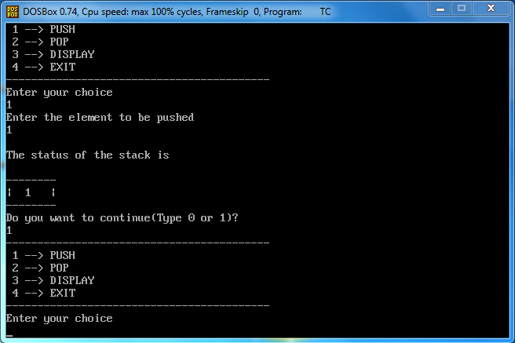

1. **Pop:**

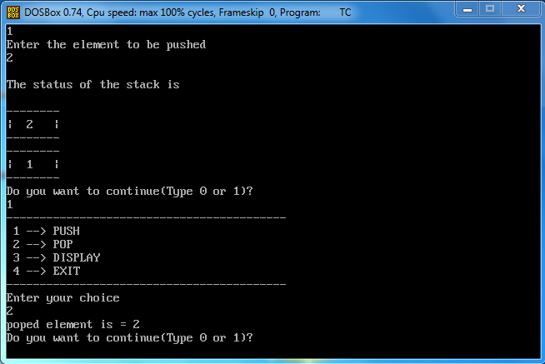

1. **Display:**

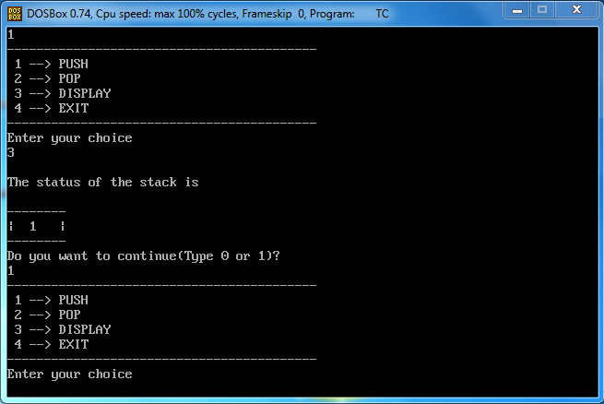

**CONCLUSION:** Hence, the program was successful, and Stack was implemented including; push, pop, display, isempty and isfull.